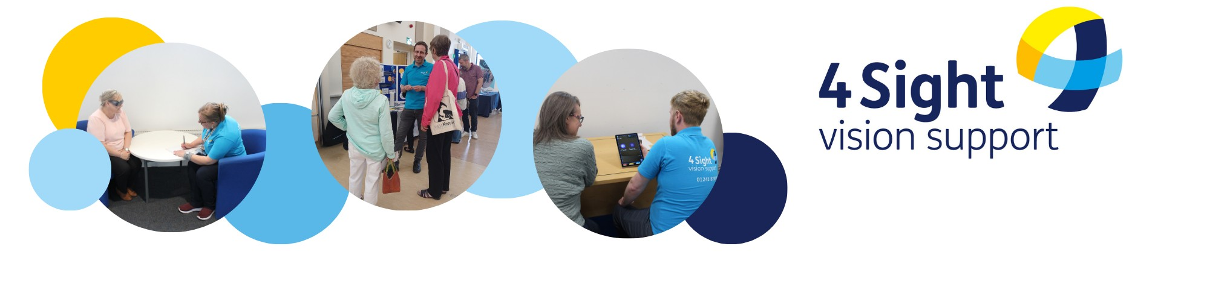
How last year’s grant was spent

Thank you so much for supporting our work. Your grant of £250 that we received in April last year, directly enabled our Team to continue supporting 3 of the blind or partially sighted residents living in the Easebourne area. In total our team have provided 1:1 support to 11 Easebourne residents.

Here are some examples of the support our Team have provided:

- Supported 2 blind or partially sighted people who weren’t already known to us, giving further information, advice and guidance on various topics.
- Provided advice and demonstrations of specialist pieces of equipment to 1 client, to ensure they are choosing the most appropriate tools and solutions for their needs.
- Made 3 telephone welfare and advice calls, to check in with our clients.
- Provided support, information and knowledge to 1 client, allowing them to make informed choices and learn to adapt to technology after sight loss.
- Provided advice to access benefits and concessions, including support with appeals, tribunals and assessments, to 1 client.
- 1 client attended one of our organised events where we can bring clients together to connect with others in a similar situation, share experiences and support each other, as well as connect with other local support organisations and suppliers of equipment that might help them.
- Sent 54 newsletters to residents of Easebourne: our newsletters are published every other month with information, advice and activities that they might find useful, in a choice of accessible formats: audio (CD or USB), Braille, large print, standard print or email.

Case Studies

Mrs A, aged over 85, living with her husband in Easebourne. Mrs A is living with Macular Degeneration and was referred to us by her optician in October 2024. We have been able to support Mrs A while she is seen in St Richards Hospital with investigations into her sight, enabling her to complete a Certificate of Visual Impairment – which unlocks various avenues of support. We have been able to advise Mrs A’s family on how to apply for concessionary passes, and have kept in touch with our newsletter. We have been able to make referrals to other support services, allowing Mrs A to make adaptations to her home. We continue to keep in touch with Mrs A checking in with her to see if her or the family need any additional support.

Mrs B, aged over 70, living alone in Easebourne. Mrs B is living with Macular Degeneration, and was referred to us my the Macular Society group. Mrs B has been a client with us since March 2017, when she came to us for some advice on technology including using a Kindle. Mrs B has received support on changes in technology and use from 2017 to date. More recently we have been able to support Mrs B with setting up accessibility on her tablet and mobile phone enabling her to keep in touch with her family and friends.

Mrs B has now been diagnosed with additional health care issues affecting her sight which mean that her sight has further deteriorated. We have been able to support the family, and Mrs B in changes to her existing equipment to allow her to best use them with her remaining sight. We continue to keep in touch with Mrs B with our bi-monthly newsletter via email, and remain in contact with the family for any additional support as needed.

Clients have been very grateful for our support, here are just a few words of thanks and appreciation:

“You have been helpful in many, many ways. You really do care. You have been a blessing” Chichester District Resident

“"If anything, else you have done, you have made an old lady very happy and saved myself and my family unnecessary expense in something that I would not have benefitted from. I never knew I had Technology already in my possession which I could of been using all along".” 4SVS Client

